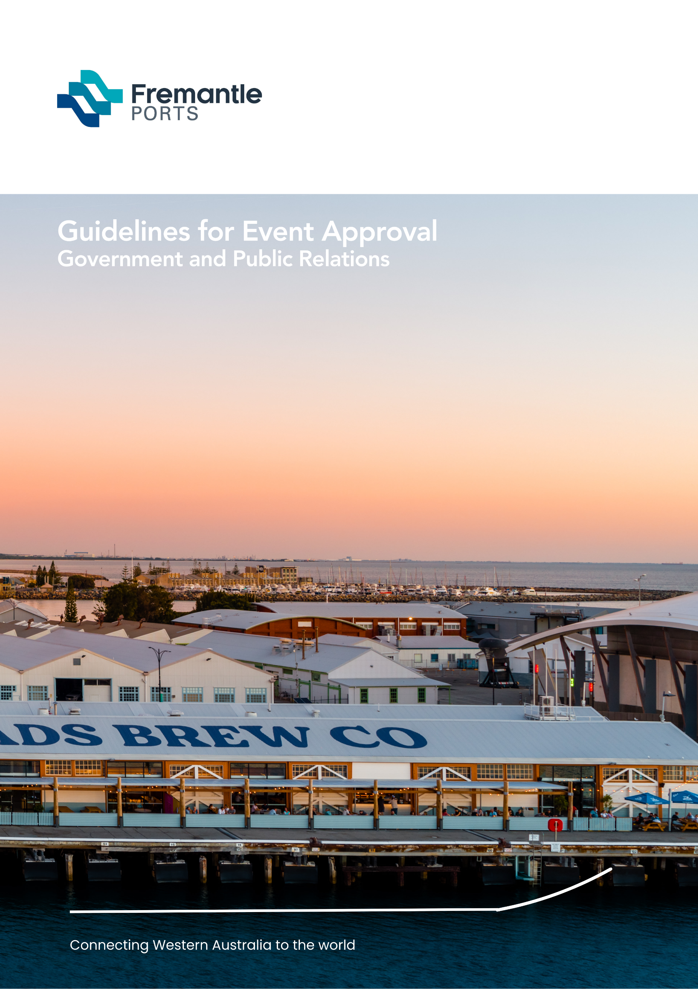
Guidelines for event approval
Government and Public Relations

Document Title
Sub Title

Table of Contents
Introduction 3
Application to conduct an event 3
Event description 4
Compulsory event details required 4
Water-based events 4
Risk Management Plans 5
Safety and environment plan 6
Emergency plan 7
Traffic and parking management plan/s 7
Public transport 8
Entertainment, food and drinks 8
Sale and consumption of alcohol 8
Sale of food 8
Promotions 9
The venue 9
Services 9
Other details - insurance, indemnity, venue plan 10
Plan of the area 10
Indemnity 10
Public/product liability insurance 11
Advertising (public notices, websites, media) 11
Contact details 12
Website information 12

Introduction
These guidelines are provided to assist individuals and/or organisations wanting to apply to hold an event either within Fremantle Ports’ boundaries or in conjunction with other non-port events such as festivals, street parades and concerts that are held near the port and may impact on its operations or the port tenants or stakeholders.
The information contained is provided only as a guideline to outline Fremantle Ports’ requirements. Some planned events may require additional specialised information.
Fremantle Ports will consider approving events and activities within its boundaries. Please be aware, however, that port operational needs always take priority, and event dates and times may be subject to change at short notice.

Application to conduct an event
Please email Fremantle Ports Corporate and Community Relations branch at: governmentpublicrelations@fremantleports.com.au with an outline of your event proposal before completing the Fremantle Ports External Event Application as some types of events are not permitted.
Any event or activity held within the port boundary requires the written approval of Fremantle Ports. A minimum of 60 days’ notice is required to process an event application.
The Port Authorities Act 1999 and Port Authorities Regulations 2001 apply to all events approved by Fremantle Ports.
Fremantle Ports may grant “in principle” approval for an event to proceed but reserves the right to cancel or limit the event because of port operational requirements, or the operational requirements of Fremantle Ports’ tenants or stakeholders at any time.
The Event Organiser/s must clearly understand that any involvement of Fremantle Ports, or its assets, may incur charges payable by the Event Organiser/s to ensure the event is cost neutral to Fremantle Ports. This includes, but is not limited to, the use of Fremantle Ports’ staff, infrastructure and equipment.
Event Organiser/s may be required to attend a meeting to discuss the potential impact of the event on port operations and other stakeholders. The applicant will be formally advised if the application requires amending, or if it has been approved or rejected.
If the event is approved, the Event Organiser may be required to attend a debriefing within seven (7) days of completion of the event.
Fremantle Ports Community Engagement Specialist will contact you to discuss your proposal once it is received. If you obtain approval to proceed with an application, please submit your application at least 60 days before the proposed event via email to: governmentpublicrelations@fremantleports.com.au

Event description

Land-based event
A general overview of the proposed event must be provided; e.g. a cycling event, triathlon, fun run or walkathon including the event's objectives.

Water-based event
A general overview of the proposed event is to be provided; e.g. swim, paddle, yacht/boat race and the event objectives.
The Harbour Master will assess all applications for water events based on the appropriateness and potential to impact on commercial shipping and port operations.

Water-based and land-based activity
If an event involves water-based and land-based activities, the application will be assessed at two levels. Corporate and Community Relations will assess the land-based activities and approval to conduct water-based activities will be granted/declined by the Harbour Master.

Compulsory event details required
Event applications must be submitted using the Fremantle Ports External Event Application and contain all the information as requested. Please make sure you include full details and all relevant attachments. Fremantle Ports may contact you for further information if required.

Water-based events
Applications for water-based events are to be submitted using the Fremantle Ports External Event Application and contain all the relevant attachments. Water-based events may be approved, provided they do not interfere with commercial shipping movements and port operations. However, this is at the Harbour Master’s discretion.
Event Organisers must comply with any further conditions as set down by the Harbour Master who has overall control of the event. Please also note the following which may be helpful in preparing your application:
- Commercial shipping needs have priority and timings may need to be altered on the day of the event to accommodate port operations.
- The Event Organisers of the event are responsible for conducting the event and are required to have sufficient staff available for operating marshalling and rescue boats, etc. Fremantle Ports cannot provide any resources.
- The Event Organisers must identify the number and type of vessels participating at the time of the application.
- The number of activities and their duration must be included in the application. The total duration of the event shall not exceed two hours except in the case of international events where finishing times may span several hours.

- A drawing showing the event course must be provided with the application and cannot be altered after approval.

- At the discretion and request of the Harbour Master, all activities must stop, and the area must be cleared for the reasonable movement of commercial vessels within the port.

- Racing vessels must keep clear of all commercial vessels in the Fremantle Inner Harbour.

- Starting/finishing/turning/rounding buoys or markers are to be removed for commercial vessels and/or tug movements.

- Official control craft must be properly and adequately marked for easy identification and be contactable by radio on a frequency nominated by the Harbour Master. All craft must remain available and contactable at all times for the duration of the event.

- If the Harbour Master decides, because of weather or other conditions or port needs or for any other reason, that the activities are to be suspended or cancelled, the order must be complied with immediately.

- Events are not to interfere with the safe navigation, or with the equipment necessary for the safe navigation, of vessels in the approaches to or within the boundary of Fremantle Ports.

- It should not be assumed that any areas would be allocated exclusively to the event.

- It is the Event Organiser’s responsibility to ensure that the flow of small craft will be restricted so as not to interfere with the particular activity, by ensuring that the movement of these craft will be under the joint control of the Department of Transport - Marine Division and the WA Water Police.
Event Organisers are required to place a public notice in The West Australian newspaper with advice for small craft owners. A copy must be forwarded to Fremantle Ports.

Risk Management Plans
Before submitting the Fremantle Ports Event Application Form, the Event Organiser is required to have conducted an assessment to establish all safety, health and environmental risks associated with the proposed event. Such an assessment needs to be conducted by competent personnel and submitted in a Risk Management Plan.
The Risk Management Plan must detail loss exposures associated with the event and the control measures which are to be implemented to manage these. In respect to implementing the control measures, the Event Organiser must outline in detail what steps are to be undertaken, by whom, at what point during the event, and to what standard.

You will be required to submit a Traffic and Parking Management Plan detailing control measures for the event that includes placement of signage, barricades and trained and approved traffic controllers at your expense.
Details on how you intend to manage the participants and spectators and ensure their safety in all circumstances are required. Details of who and how this will be undertaken must be supplied and communicated. A Communication Plan is required as a component of the Risk Management Plan and Fremantle Ports requires evidence that this has been tested to ensure that key contacts are identified, aware of their roles and able to be contacted immediately before and when the event is occurring.

Safety and environment plan
Users of any port facilities and infrastructure must acknowledge their responsibility in preserving human safety and protecting the environment.
Event Organisers must be mindful that Fremantle Port is a working port, and as such, Fremantle Ports has a duty of care to ensure that safety provisions are undertaken at all times. Unimpeded access and egress by emergency vehicles and personnel takes priority.
Any event-related equipment or structure that obstructs port safety requirements may also be removed. The wharf apron on Victoria Quay must also be kept free of vehicles or any structure at all times. All construction must be undertaken in accordance with WorkSafe regulations.

Safety and environmental risk assessment
Your Risk Management Plan should be thorough and for example include details for all the questions below:
- Does the event involve the storage, handling or transport of hazardous materials? If yes, please provide quantity and types and information on how it will be managed.

- Does the event intend to involve the use of explosives or pyrotechnics? Please note that Fremantle Ports does not allow pyrotechnics in or near the Inner Harbour in Fremantle.

- Will the event attract more than 2000 people? If yes, give estimate of numbers, average duration of attendance and details regarding crowd control and management. Details of security companies and WA Police Force assistance are required.

- Does the event require special approvals/licences? If yes, please obtain and provide copies.

- Does the event require the introduction of heavy equipment/vehicles into the port area?

- What first aid provisions will be in place for the duration of the event?

- Has an Emergency Plan been prepared that integrates into Fremantle Ports’ Emergency Plan? Fremantle Ports’ requirements will be outlined at a meeting.

- Will the event involve equipment or activities that generate excessive noise prior, during or after the event? If yes, detail noise management measures.

- Is dust likely to be generated prior, during or after the event? If yes, detail dust management measures.

- Will any artificial outdoor lighting be introduced into the port area?

- Will there be any large structure or equipment with highly reflective surfaces introduced into the port area?

- Will there be any objectionable odours, noxious fumes or smoke associated with the event?

- Is there potential for spillage of any materials (e.g. oil, toxins) that may enter stormwater drains or port waters? If yes, detail spill prevention and management measures.

- Will the event impact on port operations, tenants, port users, stakeholders or the public?

Emergency plan
Some events or activities will require a detailed Emergency Plan that is linked to Fremantle Ports’ Emergency Plan. This will be decided by the Harbour Master. Fremantle Ports’ plan and the required link will be discussed with you prior to the event and must be outlined in the Risk Management Plan.
All personnel involved in an event, including organisers, competitors, and volunteers need to be well briefed on the Emergency Plan with hardcopies of emergency telephone numbers, evacuation procedures and emergency assembly areas. Fremantle Ports requires evidence that the communication component has been tested to ensure that key contacts are aware of the roles set out for them and are able to be contacted during the event.
In some instances, your Emergency Plan should also be given to the WA Police Force. Event Organisers also have a duty of care to notify nearby hospitals about their event.
Event Organisers must also take responsibility to place appropriate public notices in newspapers advising of any road closures or changes to parking or traffic movement.

Traffic and parking management plan/s
If your event has the potential to attract large numbers of spectators to the port area, you are required to address traffic and/or parking management and provide a detailed Traffic Management Plan.
Parking on Victoria Quay has time limits and parking fees apply. Event Organisers will be charged for loss of parking revenue to Fremantle Ports if this occurs as a direct result of the event.

Reserved parking bays
Fremantle Ports is unable to provide reserved parking bays. Fremantle Ports’ parking contractor is Wilson Parking.

Parking for persons with disability
Parking bays for disabled are available in several locations on Victoria Quay. In addition, any vehicle displaying an ACROD permit or Companion Card can park for free in standard bays.

Bus/coach parking
There are several short-term parking bays on Victoria Quay for buses and coaches.

Public transport
Due to the limited parking facilities available in and around Fremantle Port, Event Organisers are requested to promote the use of public transport and the City of Fremantle’s free CAT bus service.
In the Inner Harbour in Fremantle, patrons can take advantage of the ferry services that operate from O’Connor Landing on Victoria Quay. Victoria Quay is a short walking distance from the Fremantle Railway Station which provides suburban rail and bus services.
Public transport information can be obtained from the City of Fremantle (https://www.fremantle.wa.gov.au/trains-and-buses) and Transperth. Information on ferries to and from Perth and Fremantle is available at https://www.victoriaquay.com.au/ferry

Entertainment, food and drinks

Sale and consumption of alcohol
In accordance with Port Authorities Regulations 2001, Fremantle Ports reserves the right to refuse an application for the sale of any items including liquor, on its premises. The Event Organisers are required to obtain the appropriate Liquor Licence for the sale and consumption of alcohol and Fremantle Ports’ approval is also required. Details of the proposed sale and consumption of alcohol at an event held within Fremantle Ports’ boundaries are to be included in the application.

Sale of food
Events/activities that include enterprises that are in direct conflict with businesses located within Fremantle Ports’ boundaries will need approval of those stakeholders, e.g. food vending, souvenirs, tours, etc. In addition, sale of food in a public space requires written approval from the City of Fremantle and/or the Health Department.

Promotions
The application must include details of any activities that are expected to be included in the event, such as:
- all entertainment (live performance, etc.)
- sound and stage
- amusements
- exhibitions
- transport to event
- advertising
- signage/banners
- sponsorship details.
Note: A detailed timeline showing bump-in and bump-out for all activities must be included in the application.

The venue

Refuse/litter
Management of refuse/litter is the responsibility of the Event Organiser. Details of arrangements to manage refuse/litter and its disposal from the occupied area within 24 hours of event completion, including footpaths and roadways where applicable, are to be provided in the application.

Toilets (including those with facilities for persons with disabilities)
In keeping within the Health Department’s guidelines, an adequate number of portable toilets and signage must be installed on-site by the Event Organiser.

Vacating the area
When vacating the site, or ‘bumping out’, all refuse including advertising signage and banners must be removed to the satisfaction of Fremantle Ports and the area must be left in a clean and tidy condition. Failure to comply with this condition will result in a charge to the Event Organiser for any necessary work being undertaken to make good the area.

Services
The application is to include details of other services that may be required for the event, and these are listed below.

Fremantle Ports Excavation Permit (compulsory)
Where approval has been granted for an activity that requires the breaking of the ground (i.e., installation of marquees, tents, etc.) an Excavation Permit is required from Fremantle Ports and must be clearly marked on a venue map with the proposed layout of tents/equipment. The timing of this work must be included in the application (see Vacating the Area).

Electrical services
Details identifying electrical service requirements are to be included with the application. Charges apply for the provision of Fremantle Ports’ staff in relation to advice and assistance with power usage and for the use of any port power. Electrical work cannot be undertaken on port land without prior approval of Electrical Services and this includes the use of generators.

Water and sewerage connections
Water and sewerage connections are not available and cannot be provided by Fremantle Ports. Any equipment requiring either water or sewerage or both is to be self-contained, and all waste is to be disposed off-site. Please supply full details.

Additional facilities
As a working port, Fremantle Port has limited public amenity facilities. The Event Organiser is responsible for provision of additional portable toilet facilities and therefore must liaise with the relevant authority (e.g., City of Fremantle, Health Department) in relation to the number of toilets, including toilets for disabled. The placement of portable facilities needs to be discussed and agreed with Fremantle Ports. Please show proposed sites for toilets on the venue map and include information from the relevant authorities.

Heritage approval
Breaking ground or fixing anything to buildings that are within the Heritage Precinct of Victoria Quay requires Heritage Council approval. Details must be included in the application.

Other details - insurance, indemnity, venue plan

Plan of the area
A detailed plan of the course, route, road closures, placement of marshals and other requirements is to be included with the application. Activities that require a plan or course, e.g., triathlon, marathon, walkathon, yacht race or parade, will not be processed if a plan is not included with the application. A detailed layout of marquees, stages, toilets, etc. is required.

Indemnity
Fremantle Ports requires an indemnity to be signed by the Event Organiser or a person duly authorised on behalf of their organisation. The indemnity extends to contractors and others engaged by the Event Organiser. The indemnity form (available for download from the Fremantle Ports website) is to be signed and witnessed and submitted with the original posted to Fremantle Ports.

Public/product liability insurance
Fremantle Ports requires a copy of the Certificate of Currency for Public/Product Liability Insurance Cover. Insurance details are to include:
- Event Organiser’s details
- event date
- event name and type (e.g., triathlon).

Event Organisers are required to discuss appropriate insurance requirements with Fremantle Ports prior to the event being approved as the amount of insurance required differs for each event.
Note:
- Product liability insurance is required if the event has enterprises where consumables are sold.
- Insurer’s statement or invoice is not sufficient.

Advertising (public notices, websites, media)
Road closures that affect entry and exits to and from Fremantle Port are to be agreed and advertised prior to the event. The advertising schedule is to include a public notice for small craft if water activities are included. (Details are available from Fremantle Ports). Advertising is to include a plan or map indicating the closed roads and details of parking and public transport available. All advertising costs must be covered by the Applicant.

Signage
Small directional ‘A’ frame signs are permitted leading into Fremantle Port on the day of the event, if the City of Fremantle and Main Roads Western Australia approvals have been granted. The signs must be securely anchored and removed on the last day of the event by the Event Organiser. Fremantle Ports may approve the placement of additional signage within the port boundary, however; this needs to be clearly defined and marked on venue maps that accompany your application. The cost of signage must be covered by the Applicant. Fremantle Ports reserves the right to remove and dispose of any obstructive, inappropriate or undeclared signage prior to, during or after an event.

Barricades
Barricades are not provided by Fremantle Ports. Fremantle Ports may allow the use of barricades depending on their proposed location, the type of event, the number of expected attendees and port operational requirements. Provision, positioning and removal of the barricades are the responsibility of the Event Organiser. Details of areas requiring barricades are to be included in the application and indicated on the Event Management Plan.
Note: Barricading of port roadways in and around North Quay and Rous Head Industrial Park is not permitted. Requests to barricade roadways or parking bays on Victoria Quay must be outlined in the application and this request will only be considered in relation to port and stakeholder requirements. Please refer to the Traffic Management section for further details.

Fireworks
The use of fireworks is not permitted within Fremantle Ports’ boundaries.

Physical details
The Event Organiser is to include relevant information of physical factors if the event includes vehicles other than motor vehicles. Dimensions (height and width and weight) of trucks, cranes and festival-type floats are required. Dimensions of banners, tents, fencing, marquees, lighting and sound equipment must be supplied. Details of any other hire equipment must be supplied including the name of the hire company.
Note: Drop-off and pickup times of hire equipment must be listed in the bump-in and bump-out schedule that forms part of the event program.

Approvals
Copies of other approvals (local or State Government agencies or private organisations and event beneficiaries) are to be included in the application. Applications cannot be processed until all approvals have been submitted.

Contact details
In the application the contact details of each person who has a major responsibility in organising the event should be submitted and that includes:
- name
- position and area of authority (e.g., traffic management)
- mobile telephone (for the duration of the event)
- contact telephone numbers
- email address.
Contact details of the personnel responsible for the event Risk Management Plan and the overall Event Manager on the day of the event are essential.

Website information
Please refer to the Fremantle Ports, Victoria Quay and City of Fremantle’s websites when proposing an event to ensure that it does not conflict with other major events being held in and around Fremantle at that time. Fremantle Ports’ website has information on the cruise ship schedule (https://www3.fremantleports.com.au/VTMIS/).

